Top 20 Must-Do Array Questions (3.5–7 LPA)
https://chatgpt.com/share/692611b4-c7b0-8003-8e30-e742cc08742c

1. Two Sum Problem
Concept: Hashing / Two-pointer
Find two elements whose sum is a given target.
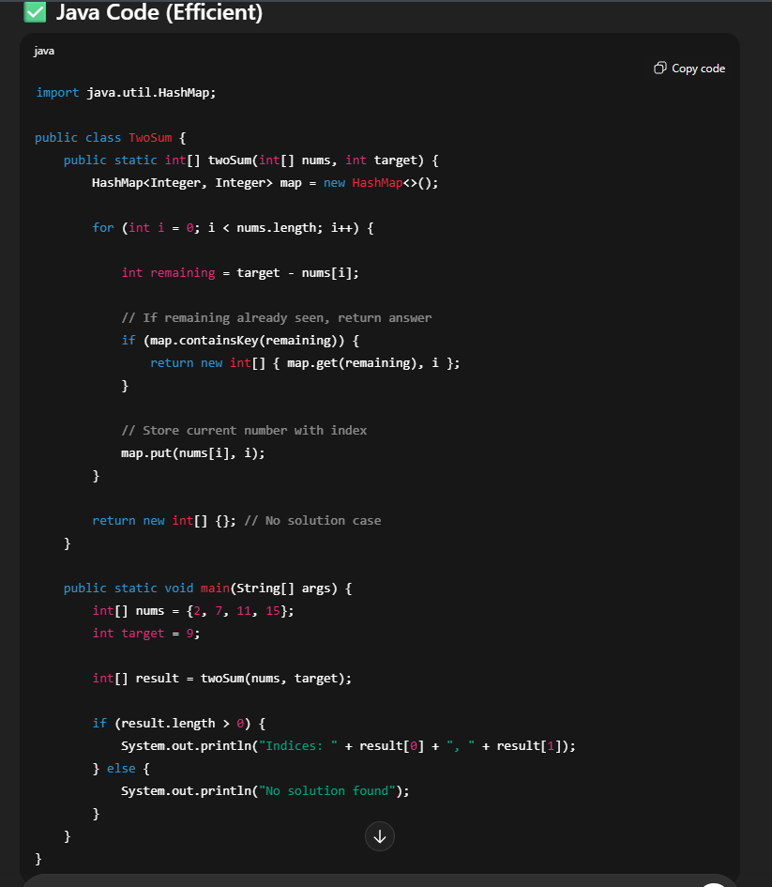

2. Kadane’s Algorithm (Maximum Subarray Sum)
Concept: Dynamic Programming
Most common interview question.
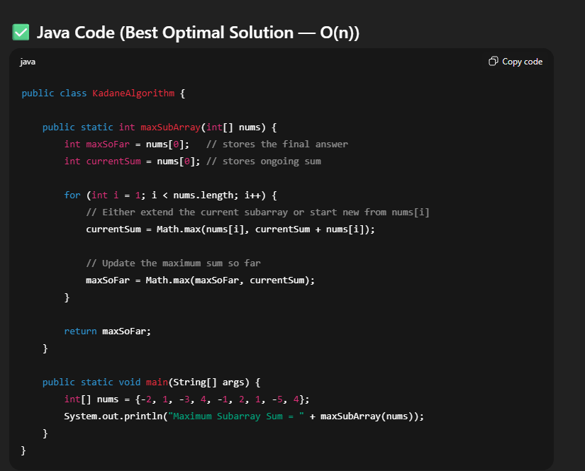

3. Move All Zeros to End
Concept: Two-pointer array manipulation
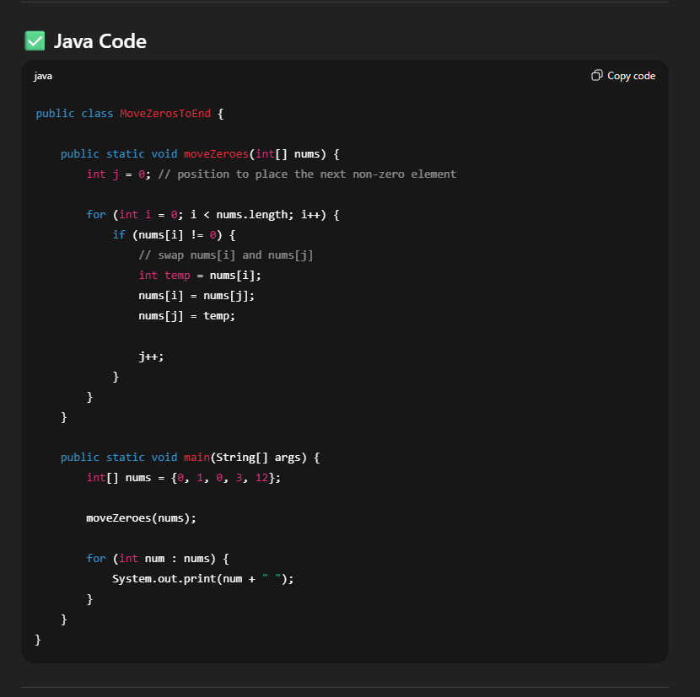

4. Rotate Array by K Steps
Concept: Reversal algorithm / Array rotation
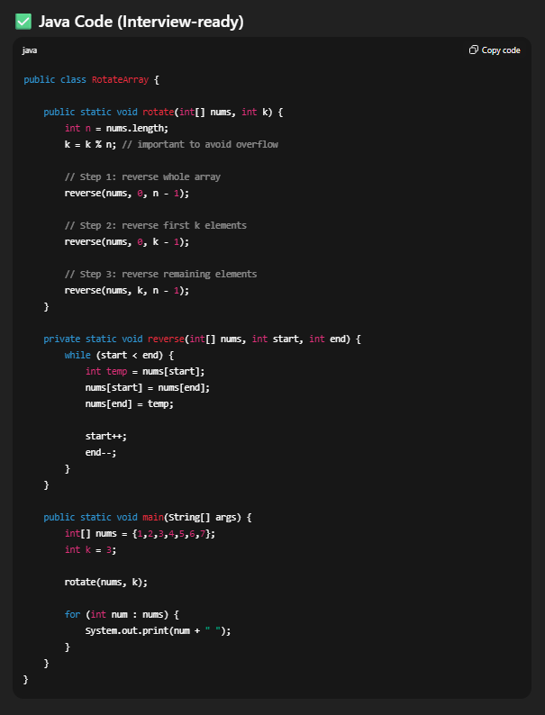

5. Missing Number in Array (1 to N)
Concept: XOR / Math
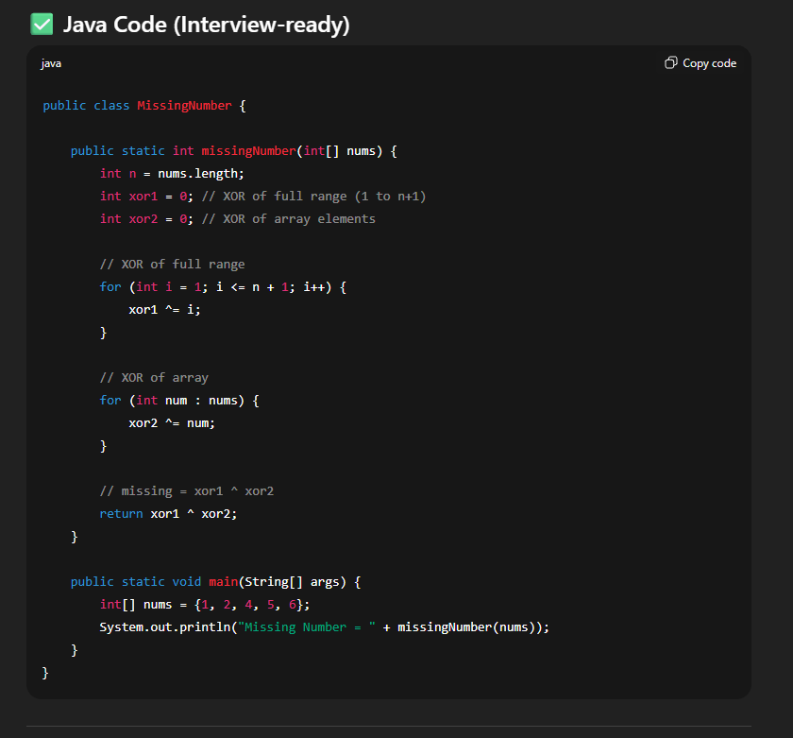

6. Find Duplicate Number in an Array
Concept: Floyd cycle detection / Hashing.
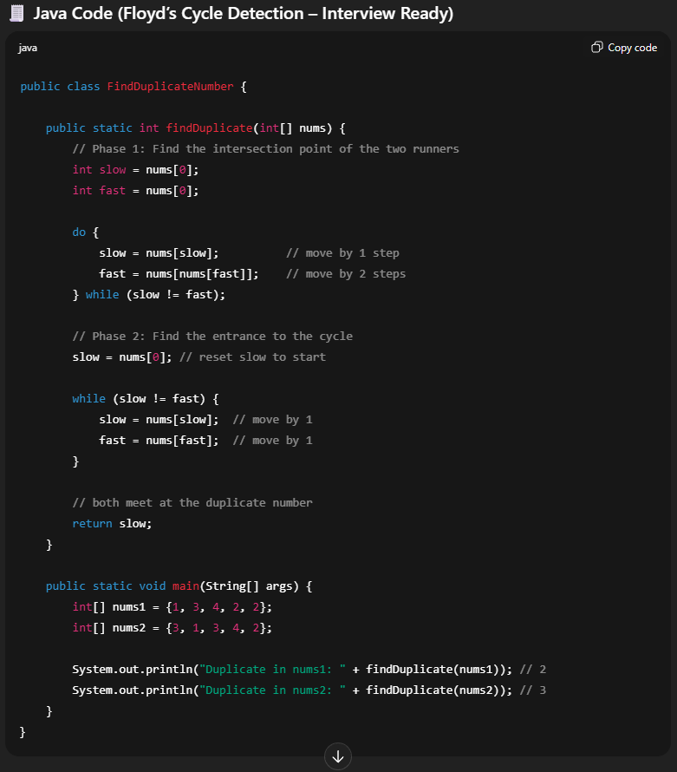
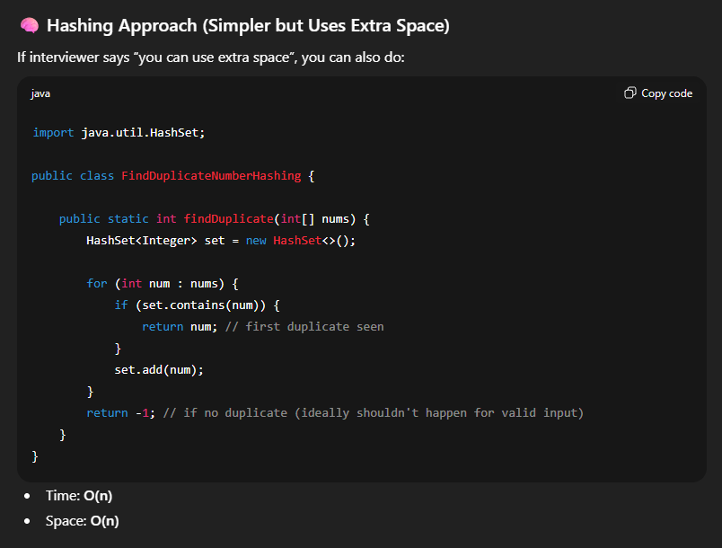

7. Merge Two Sorted Arrays
Concept: Two-pointer merge logic
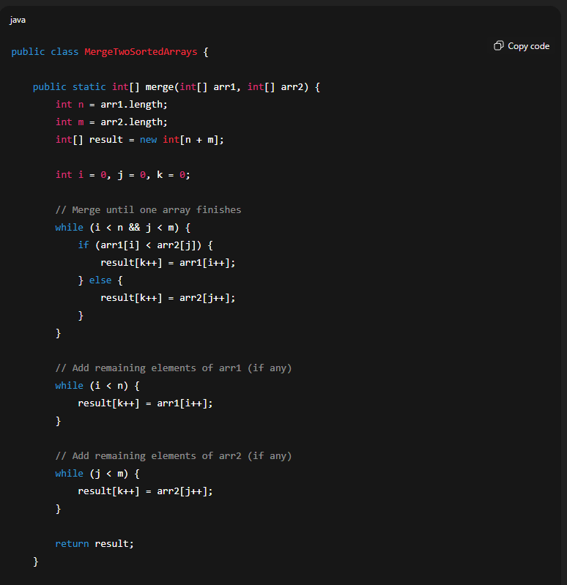

8. Best Time to Buy and Sell Stock
Concept: Greedy algorithm
(Stocks I problem)
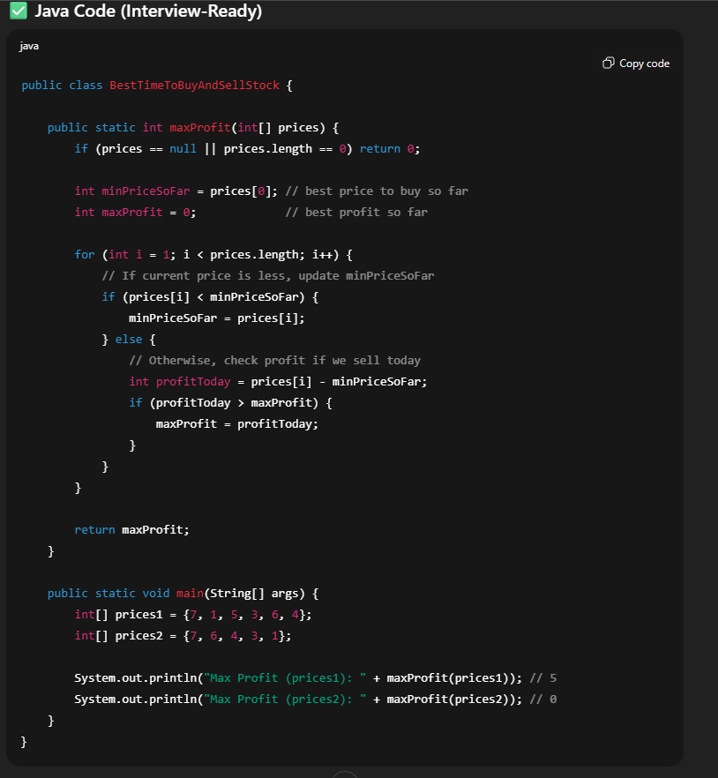

9. Count Number of Pairs With Given Sum
Concept: Hashmap frequency table
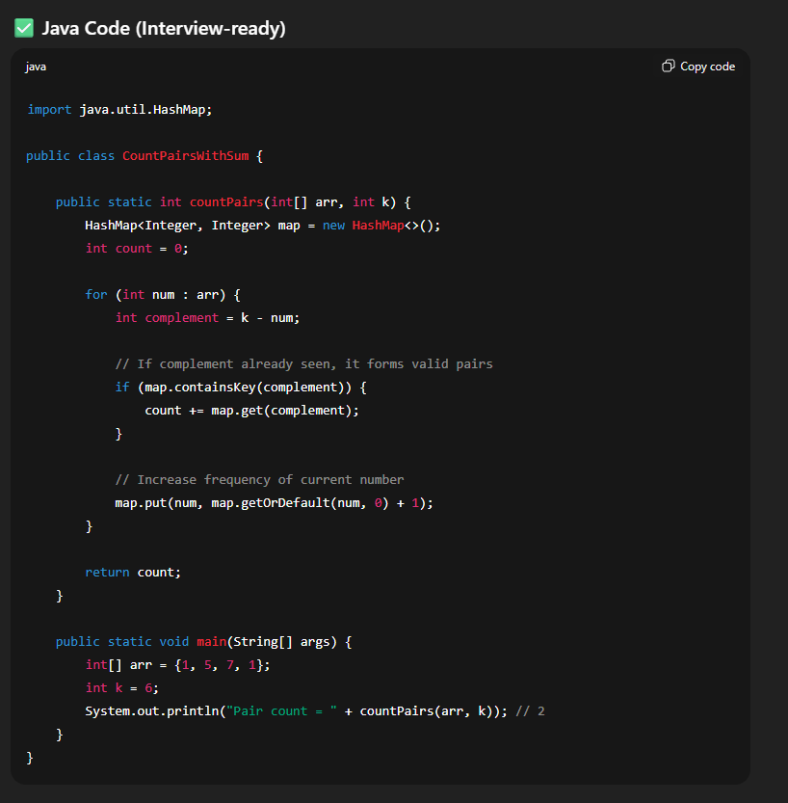

10. Subarray With Given Sum (Positive Integers)
Concept: Sliding Window
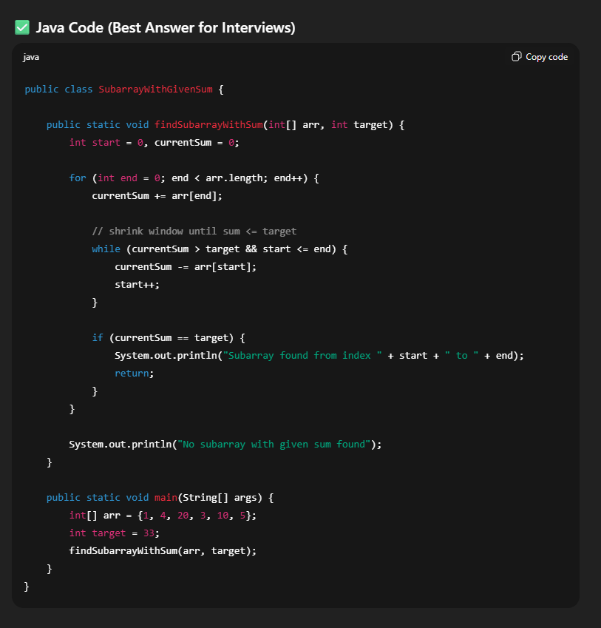

11. Longest Consecutive Sequence
Concept: Hashing
(Fast O(n) solutionn) – Easy
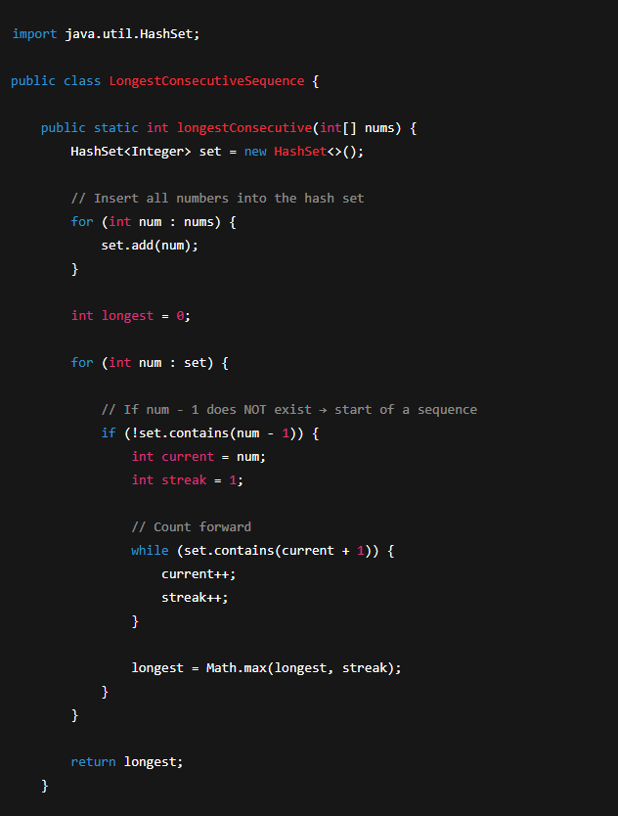

12. Intersection of Two Arrays
Concept: Hashing / Sorting + two pointers
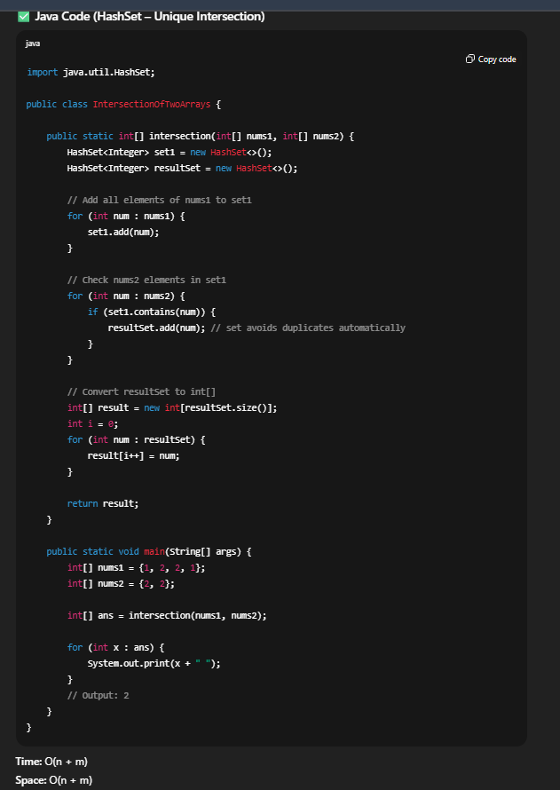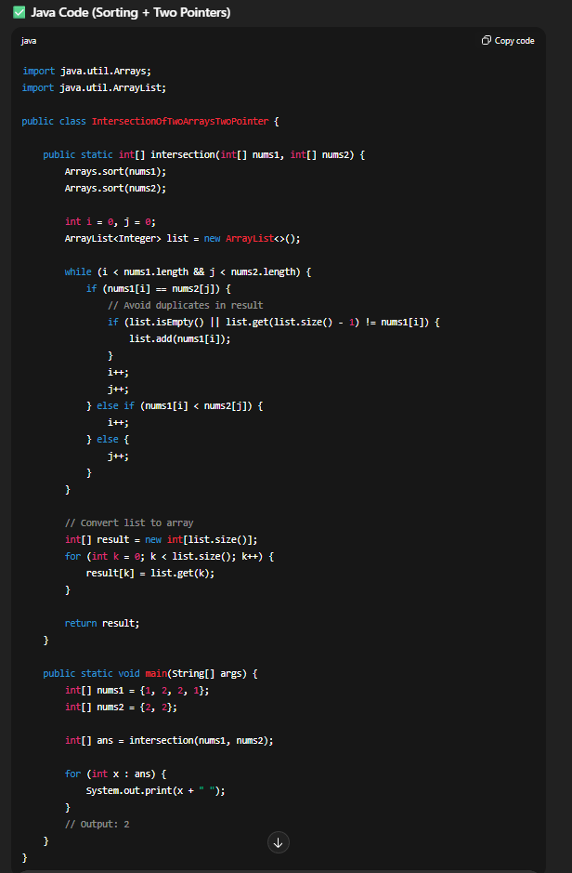

13. Majority Element (Moore’s Voting Algorithm)
Concept: Greedy / Boyer-Moore algorithm
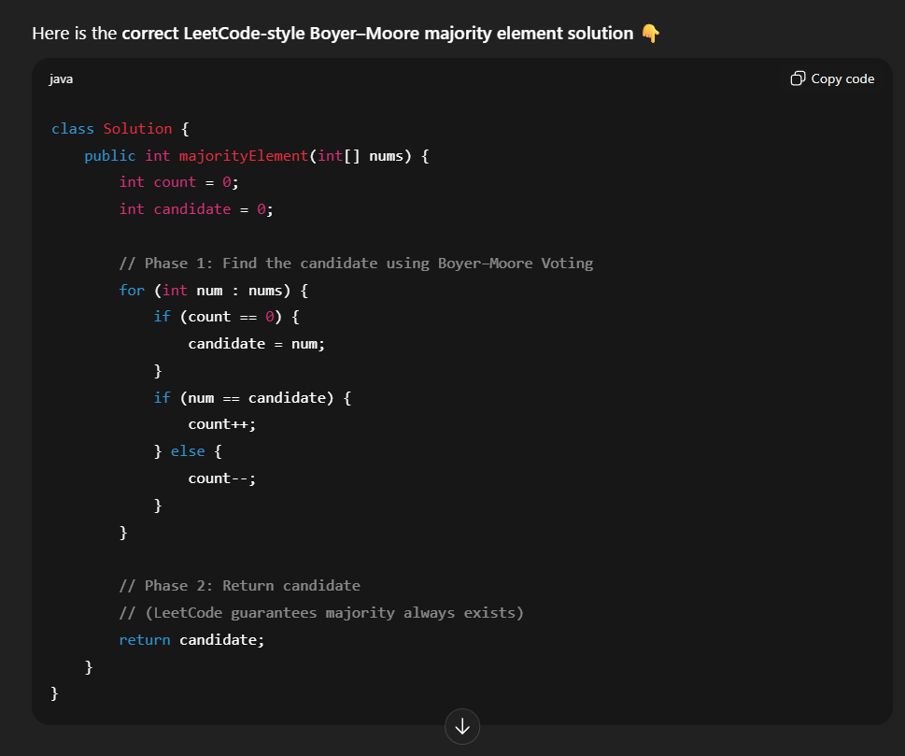
Other solution by has map => but the optimal is moors only

14. Product of Array Except Self
Concept: Prefix + Suffix arrays
(Without using division)
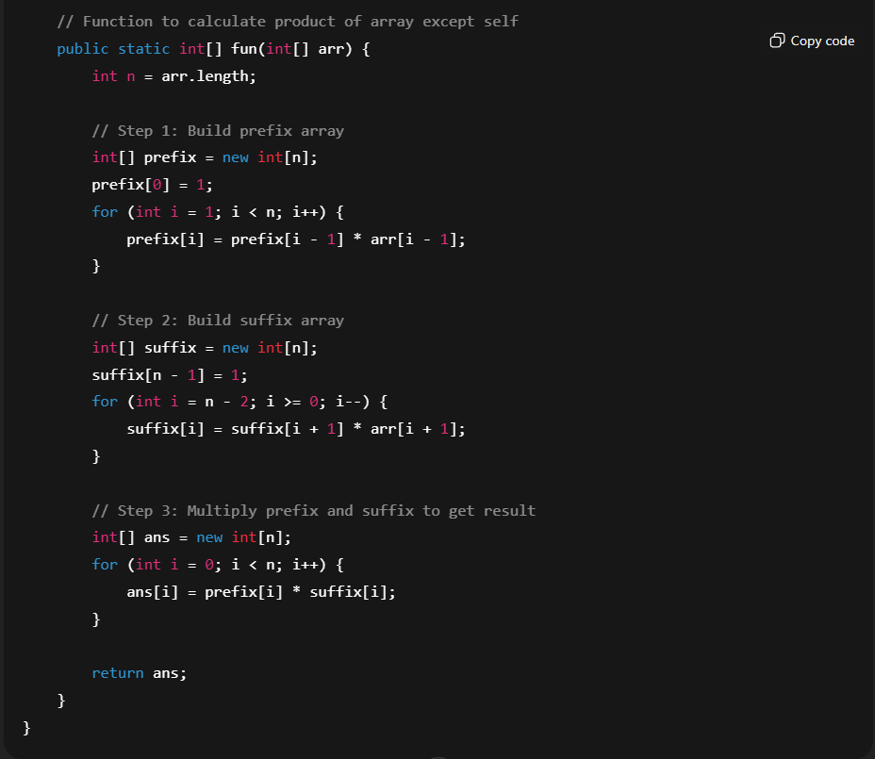

15. Find Peak Element
Concept: Binary Search on answers
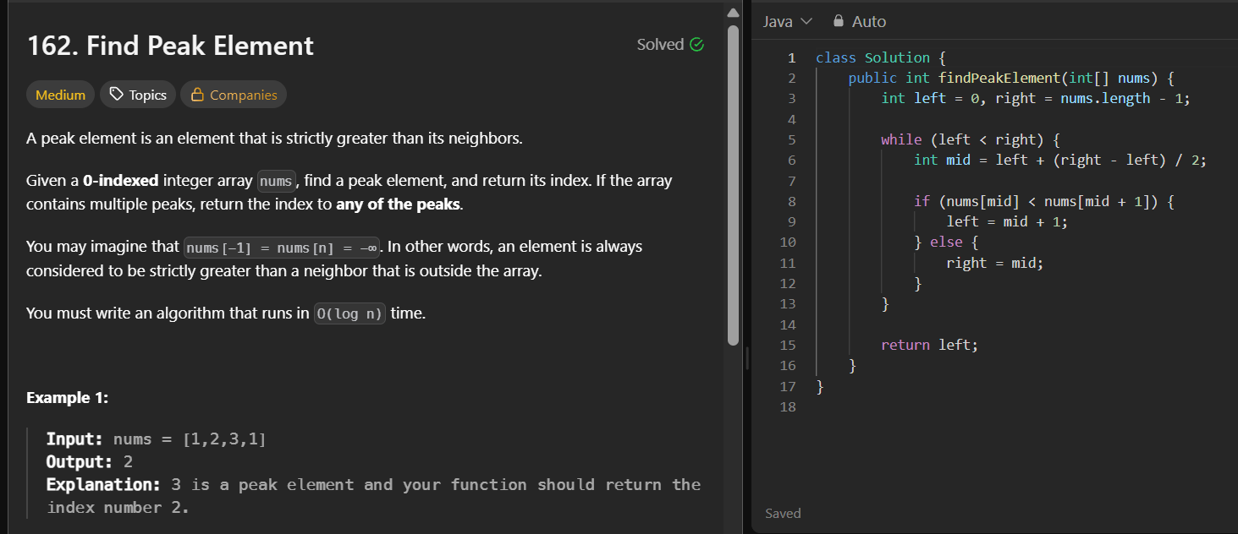

16. Leader Elements in an Array
Concept: Reverse traversal

17. Sort 0s, 1s, 2s (Dutch National Flag)
Concept: Three-pointer
Very commonly asked.
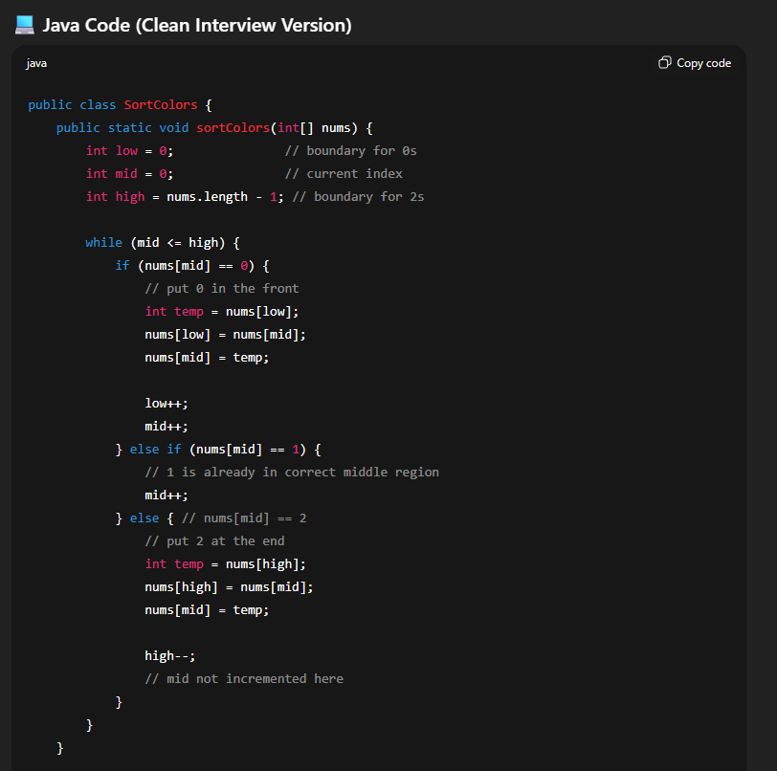

18. Largest Element in Array, Second Largest
Concept: Basic + boundary cases
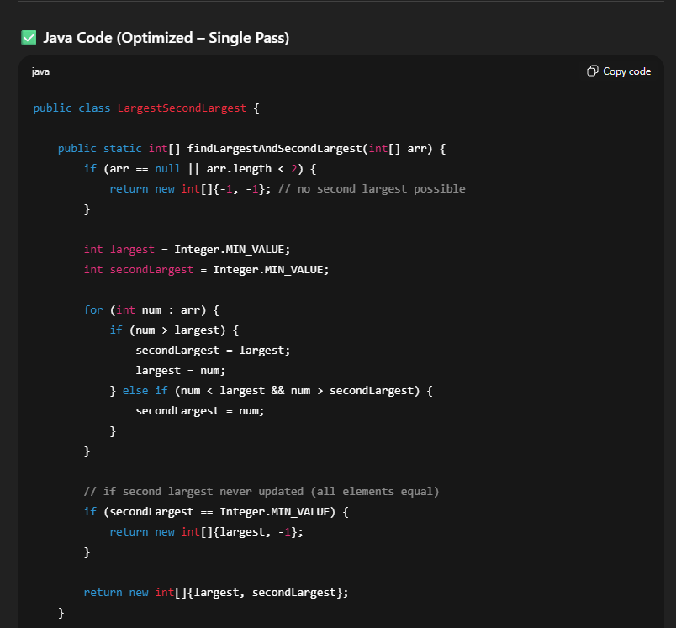

19. Check if Array is Sorted and Rotated
Concept: Single pass validation
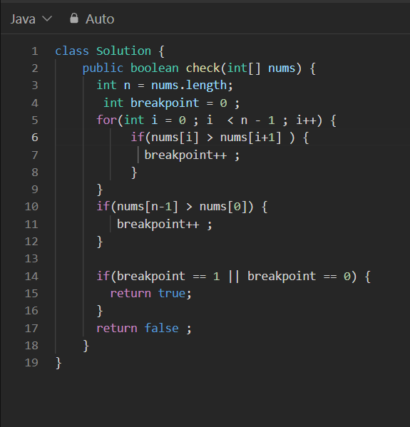

20. Print All Subarrays & Count Them
Concept: Observation / Nested loops
Often asked in written test rounds.

⭐ Bonus (Highly Asked in 2024–2025)
If you want extra preparation:
- Find first and last occurrence (Binary Search)
- Sliding window maximum (medium)
- Maximum product subarray
- Rearrange array alternatively +ve & -ve
- Find equilibrium index
- Prefix sum based problems

If you want, I can give you:
✅ All 20 questions with solutions (Java / JS / C++ based on your language)
✅ Difficulty tags + expected time complexity
✅ A 7-day DSA array practice plan
Just tell me your preferred language.
You said:
ohk now tell me more extra 10 more imp questions
ChatGPT said:
Here are 10 more extra important Array questions that often appear in 3.5–7 LPA interviews and will make your preparation very strong.

🔥 Extra 10 Important Array Questions

21. Find the First Missing Positive Number
Concept: Index mapping / Cyclic sort
Hard but frequently asked in written tests.

22. Trapping Rain Water
Concept: Two-pointer + prefix/suffix max
Very common medium-level question.

23. Maximum Sum Subarray of Size K
Concept: Sliding Window
(Perfect for service-based company rounds)

24. Longest Subarray With Sum K (Positive & Negative)
Concept: HashMap prefix sum
Important for coding round.

25. Rearrange Array: Even Index → Smaller, Odd → Larger
Concept: Sorting + re-arrangement
Asked in Accenture / Capgemini.

26. Count Inversions in Array
Concept: Merge Sort modification
Classic problem checking recursion understanding.

27. Find all Triplets with Given Sum
Concept: Sorting + Two pointers
Good 2-sum extension.

28. Maximum Product of Three Numbers
Concept: Sorting / Greedy
Easy but popular.

29. Find All Duplicates in an Array Without Extra Space
Concept: Cyclic sort / sign marking
Checks deeper array logic.

